EXERCISE 3

-- 1. List all employees whose last names begin with ‘P’.
SELECT F_NAME, L_NAME
FROM EMPLOYEE_DATA
WHERE L_NAME LIKE 'P%';
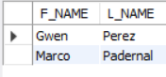

-- 2. Display the names of all employees in the marketing division.
SELECT F_NAME, L_NAME
FROM EMPLOYEE_DATA
WHERE DIVISION = 'Marketing';
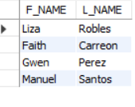

-- 3. What will the following statement display SELECT f_name, l_name, salary FROM employee_data WHERE f_name LIKE '%k%';
-- IT WILL DISPLAY THE FIRST NAME, LAST NAME, AND SALARY OF ALL EMPLOYEES WHOSE FIRST NAME CONTAINS THE LETTER “K”
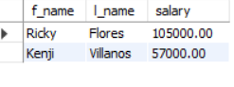

-- 4.List the last names and titles of all programmers.
SELECT L_NAME, TITLE
FROM EMPLOYEE_DATA
WHERE TITLE LIKE '%PROGRAMMER%';
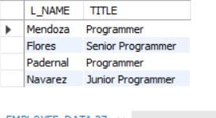

CREATE DATABASE IF NOT EXISTS EXERCISE3_DB;
USE EXERCISE3_DB;
CREATE TABLE EMPLOYEE_DATA (
EMP_ID INT AUTO_INCREMENT PRIMARY KEY,
F_NAME VARCHAR(50),
L_NAME VARCHAR(50),
AGE INT,
SALARY DECIMAL(10,2),
YOS INT,
DIVISION VARCHAR(50),
TITLE VARCHAR(50)
);
INSERT INTO EMPLOYEE_DATA (F_NAME, L_NAME, AGE, SALARY, YOS, DIVISION, TITLE) VALUES
('John', 'Cruz', 34, 80000, 4, 'IT', 'Programmer'),
('Kim', 'Ricaro', 33, 90000, 3, 'Marketing', 'Marketing Executive'),
('Paolo', 'Heymann', 35, 85000, 2, 'Sales', 'Sales Associate'),
('Ricky', 'Lopez', 45, 100000, 5, 'IT', 'Senior Programmer'),
('Danny', 'Garcia', 34, 90000, 6, 'IT', 'Software Engineer'),
('Michael', 'Hernandez', 35, 120000, 7, 'Finance', 'Accountant'),
('Fate', 'Caraan', 36, 120000, 8, 'Marketing', 'Marketing Manager'),
('Mariel', 'Cuenca', 28, 60000, 2, 'HR', 'HR Assistant'),
('Grace', 'Sarmiento', 30, 65000, 1, 'Marketing', 'Marketing Staff'),
('Mark', 'Pedernal', 27, 58000, 2, 'IT', 'Programmer'),
('Kim', 'Villareal', 26, 55000, 2, 'Sales', 'Sales Representative'),
('Manuel', 'Santiago', 40, 95000, 9, 'Marketing', 'Marketing Head'),
('Alona', 'Navarro', 31, 75000, 4, 'IT', 'Junior Programmer');

